Health and Safety Committee Meeting Minutes

Days Since Last:
OSHA Recordable Injury  212 | Restricted Work Injury  819 | Lost Time Injury  690
5/15/2024 | 9/16/2022 | 1/23/2023
 |  |  | 3/14/24 | 3/22/22

Meeting Date: | 12/13/24 | Time: | 1:30 pm
Members Present: |  | Absent:
Safety Consultant
Management
Plant 3
Plant 4
Processing
Yard
Maintenance
Office /Sales
Guest

Monthly Totals |  |  | Annual Totals
November Required Attendance  Representation from all Depts. | 8 | 100% | Yearly Attendance | Total | 85 | 96.5%
November Required Attendance  Representation from all Depts. | 8 | 100% | Goal = 90% | Total Required | 88 | 96.5%

CC:

1.0 CHAIR COMMENTS
- Nick has come back for the month to close off the year strong. Both he and I feel that the facility is a really good spot. There have been no major safety findings that will lead to inappropriate conduct to cause an injury. Instead, it’s the small items that would be scrutinized by a compliance officer.
- Training was engaging and fun to get interaction with the videos regarding situational awareness. I know this isn’t a required OSHA topic and its difficult to train someone to have good situational awareness, but it brings thoughts about the types of behaviors and mindsets needed to think about the bigger picture and not just the task at hand.
- Biggest concern this month was found in APC due to a cleanup of testing. Alex apologized for not having it done sooner but it shouldn’t be an apology to the safety guy. We have time to take care of these things after we do testing. Production should not have to clean up other peoples actions.
- This month we were doing some digging into why the PACO operator results were higher than the rest of the Plant. We looked into the flow rates of all the dust collection systems in every Plant and will be documenting that. The ducts were clear of dust and debris but the problem could be that the system is not connected to the ceiling or there is a problem with the dust collector itself.
2.0 ROUND TABLE
Ken Edge – Plant 3
    - No accidents or injuries this month for Plant 3.
    - Conducted a 10-minute safety meeting regarding Cold weather and Ice and Snow removal as we had our first dusting of the year.
    - We are running short due to staffing. Two of our Plant operators are not working at the moment.
    - Safety observed the storage of strapping material near the strappers is creating a choke point for the forklifts and two-way traffic. Secondly stones are being used to weigh down the strapping material. we may want to look into something more secure.
Rob LaForce – Plant 4
    - No accidents or injuries were reported this month.
    - All performance reviews for Plant 4 employees have been conducted.
    - All Plant 4-night shift employees will be working on days next week. Secondly the Boss Employees’ last day is the 18th.
      - This crew will be smaller liking being a strain point as we are down in Plant 3 as well. Zach McIntyre will be on vacation as well next week, making the crew smaller.
    - SOP and PM schedules have been created for the floor sweeper. A PM still needs to be created in Manager plus. Through conversing with employees, it was found that an employee who has not been trained in its use has been using it. This could have been the potential cause of damage to the front bumper.
    - We are in the process of reviewing manager plus items for daily weekly and monthly inspections to ensure they have been done properly last year.
Processing – Aaron Casey
    - No accidents or injuries reported.
    - We have had to reiterate to select employees about wearing PPE at all times.
    - Found a safety concern in PACO. When opening the fortress gate to the wrapper, the wrapper stopped due to breaking the safety circuit, but it did not stop the rollers. The rollers are part of the conveyor system not the wrapper fortress system. These need to be tied to each other.
      - Suede: This should have been caught in the Estop checklists done on Friday.
      - Aaron Casey: this was only found because it was running during a work task. Testing and inspection are normally done with the machine not running.
      - Nick: We could put a barrier between the people and the rollers as a stop gap measure.
        - Don will work on this next week to tie it into the safety circuit.
    - There is shot observed on the floor at the back of the shot blaster in APC creating a slip hazard. The operator knew he should have cleaned it by now and said he was going to as soon as he had free time.
    - It has been two days since we inspected the Harvard product, but they are still left off the pallets in work area. We do not want to make it harder on production and give them extra work tasks. If we are doing testing, inspection or quality let’s clean up the stones and not have production have to clean up.
Sue - office
- No accident or injuries to report.
- We conducted a small workplace violence conversation with production employees during training. The office employees are the most public facing and probably are at a high risk of workplace violence. In Q1 we will be conducting a workplace violence training online.
- Alertis system is being tested and integrated into our system. We are currently in the process of looking at silent alarms and other indicator lights. A Brewster employee has been sitting in manufacturer/ service provider led webinars for its use. We should get an Uxbridge employee to these meetings. The only concern with alertis is that they are taking away the phone application in the near future. This will be an ongoing discussion of how to communicate with employees during emergency situations and weather updates.
  - We should run a live lockdown drill and or how to deal with a threat onsite sometime in 2025.
Dave Marchand
- No accidents or incidents from the sales department
- The flammable material issue from last month is being rectified. Currently we are still working on getting extra flame cabinets but have worked with our supplier to not order anymore. We do not want to send it back and forth between here and Chester.
Aaron Gelinas
- No accidents or injuries reported or observed,
- The plow has been installed on the truck and is ready to be used during any storms. As well we have installed backup cameras on the sander on the truck and the bob cat for heightened visibility for the driver.
- Crane inspections have been added to manager plus. We can now start to use crane inspection, only need to teach people about the specific checks for the inspection.
- Suede: We have just conducted training with all employees about blind spots to the loader. We made each employee sit in the loader and look for the forklift in the blind spot, so we have a heighted awareness of the limited visibility.
  - New procedure is to honk twice from forklift operators to loader and loader gives two honks back to confirm awareness when operating in the same area.
Bob Forester
- No accidents or injuries to report.
- Following a recent snow event, snow lanes were efficiently cleared during the storm, and all drains have been cleaned and are functioning properly.
- Daily discussions with employees emphasize proper PPE usage. Employees are reminded to intervene if drivers or individuals in the yard are not wearing high-visibility vests. All personnel outside of vehicles must wear vests. Consistent monitoring ensures compliance.
- With the winter ramp-up of materials, aisleways are becoming busier. All employees must use horns to signal their presence. Forklift traffic has improved, with drivers adhering to designated paths to the trash pile. Let’s maintain this progress.
- Forklifts are currently operating on compressible ground near the trash and secords yard, which risks a citation due to regulations prohibiting solid tires on such surfaces.
- Switching to pneumatic tires presents challenges, such as increased hazards like bouncing forklifts, dropped pallets, or tipping.
- Brian Adams' Input: Chester and Virginia use pneumatic tires with flat tire issues being the primary concern.
- Mark Apple Suggestion: Retrofitting an old Linde truck with pneumatic tires for this area might be a cost-effective solution compared to replacing all tires.
Don Bussolari
- ESS sent the one-line diagrams for their arc flash assessment.
- According to an email from consultant Michael Hartnett to the corporate team, OSHA is aligning its enforcement with the latest NFPA regulations. This guidance directs OSHA compliance officers to use the updated NFPA standards during inspections.
  - Mark Apple: The integration of the NFPA standard may pave the way for OSHA to accept control isolation as part of its Lockout/Tagout Standard, potentially validating Fortress as a viable energy control method.
- Efforts to reduce clutter on electrical panels in the Plants are showing progress. Minor items, such as leftover contractor stickers and a wire organizer in tumbling, have been addressed. No recurring issues involving non-maintenance personnel tampering with electrical panels have been observed this month.
Brian Adding
- Discussed water runoff and ongoing investigation in Brewster.
Dishen
- Reinforce discussions with employees about the importance of not rushing during work. Rushing has been a primary cause of quality issues and can also impact safety. This message aligns with the recent situational awareness training. Encourage employees to take a moment to perform their tasks thoughtfully—there’s no need to hurry.
Billy Chamberlain
- Acknowledging the current staffing challenges, a job fair is scheduled for January, with a few applicants already under review. While there have been delays in hiring, the focus remains on thoroughly vetting candidates to ensure a cultural fit and avoid wasting resources on unsuitable hires. Nick and I discussed how other companies often compromise on training and accountability, leading to poor outcomes. Given our dangerous processes, hiring employees with the right skills and mindset is critical. Soft skills are equally important in ensuring safety and procedural adherence.
- Suede, Nick, and James compared Training and Accountability across companies. Unilock invests significantly more time in hands-on training than many competitors, who often rely solely on online or classroom sessions. Our managers and supervisors possess in-depth knowledge of the machines, enabling them to identify both safe and hazardous conditions and proactively address issues. This hands-on approach sets us apart, as most companies’ managers lack this expertise.
- The first offsite Christmas party takes place tonight at Gia’s down the road.
- Plans are underway to conduct more tests with Aletris and integrate them with yard tablets. Suede emphasized the importance of attending Aletris’ weekly webinars to stay updated on best practices.
Jeff Baker
- Winter maintenance preparations are underway. Plant 4 will run for a week after the holidays and then shut down, while Plant 3 is tentatively scheduled to shut down on January 3rd to begin work on the dry side.
- Masa Tech visited last week and identified alignment and other issues, which have since been addressed. Replacement parts have been ordered as needed.
- Extensive testing occurred this month in both Plants and APC, focusing on shot and positive cement. Although the process was initially scattered, the team adapted well. Pre-test meetings have been conducted consistently to ensure alignment and clarity.
- Molds and pallets have been placed in front of fortress gates, posing a potential hazard. This could be addressed as part of visual management updates, alongside fire extinguishers, electrical panels, light curtains, molds, and tip dumpsters. While vinyl stickers were considered for marking, the risk of slips prevented their implementation
Suede Remington
- An alternative solution for visual management was discussed, featuring a system from Laser Glow that uses lighting instead of floor paint to guide pedestrian and forklift traffic. This system can also be applied to highlight fire extinguishers, electrical panels, light curtains, forklifts, and cranes.
- The Laser Glow system will be reviewed and tested in Brewster.
- For further details, refer to the Laser Glow PowerPoint
Mark Apple
- Nothing new to note.
James DeMailly/ Nick Pasternack
- Findings from this month’s walkthrough were reviewed with the group. Please refer to the "New Business" section and attached photos for details.
- The dust collection systems around the Plant were assessed due to elevated PACO sampling results. While these results remained below the action limit and PEL, efforts are underway to reduce levels further. Observations included:
  - The dust collector is functioning and unclogged, and the filters will be replaced today.
  - Ducting above Ram #2 was found to be improperly secured.
  - A magnaflux reading showed a full-point difference between the two dust collection points.
    - Potential Improvement: A movable filter system could be installed around the splitter. This would serve dual purposes: enhancing dust collection during PACO operations and functioning as a welding air filter system when PACO is inactive.
    - Mark Apple’s Input: During filter replacement, inspect the motor fins to ensure they are undamaged. Dust buildup could be abrasive and potentially cause wear or damage to the fins
- We’re very pleased with the safety culture in place. It’s clear that the team can maintain safe practices consistently without constant oversight. Most findings involve minor compliance issues, and overall behavior has been excellent. Your track record this year is commendable—fantastic job! Remember, the number of action items isn’t a performance indicator. Card completion has been strong, and employees are demonstrating proactive efforts.
- Boss Employees suggested having PowerPoint presentations translated into Spanish, as the current captioning system struggles during multi-person conversations. Moving forward, these materials will be translated to enhance understanding.
  - Suede is trialing real-time translation headphones to evaluate their effectiveness. Additionally, James has expressed interest in learning Spanish to better support Spanish-speaking employees.
  - Improving training tools for Spanish-speaking employees, particularly during onboarding and the critical first few weeks, will strengthen their integration into the workforce.
  - Chicago previously attempted English language training for Spanish speakers but found it counterproductive for employees that had some skill with english, leading to confusion.
  - Our current translator system, which integrates with earbuds, is a helpful tool. Boss employees have expressed a desire for more comprehensive Spanish-language information to match the depth of understanding available to the rest of the workforce. Providing this level of detail will help unify the team.
- It’s time to conduct another culture survey. Since the last survey, there have been significant changes, including staff turnover, updated processes, increased employee commitment, and improved training programs. Key takeaways from the survey can be compiled and shared with the group for discussion.
- The number of action items has been reduced by 15% compared to last year. While this isn’t a direct performance indicator of safety, it reflects a trend toward identifying less severe issues. Repeat items remain limited to a few recurring concerns, but we can continue reducing these numbers by leveraging stop work cards, enhanced training, and workforce engagement.

SAFETY INSPECTION ACTION ITEMS
2023 Total Number |  | 115
2024 Total Number (YTD) |  | 99
2024 YTD Open | 2024 YTD Closed | 2024 YTD Overdue | 2024 YTD Repeat
9 | 90 | 1 | 8
Due date ranking system | Within 24 hours | Within 3 days | Prior to next meeting
Monthly updates / corrective actions taken toward projects noted in blue.
YTD Action Item Closure Rate: 98.6%
Overdue Action Item Rate: 1.0%
Repeat Action Item Rate: 8.1%

4.0 ITEMS FROM PREVIOUS MINUTES

ITEM NO. | DESCRIPTION | ASSIGNED TO: | DATE ENTERED: | DUE DATE: | STATUS: | R/Y/G
Plant 3 / Maintenance, Paco, APC, Tumbling
1 – 11 – 24 | Tools were observed multiple times throughout the week by the same employee on top of the electrical panel at the QC Station on multiple occasions. Reinforce that electrical panels are not to be used as storage areas for tools or any other items. | All Supervisors | 11/22/24 | 11/22/24 | Closed | R
2 – 11 – 24 | Face shields were observed covered in dust in the PPE storage area near the mold cleaning area at the back of Plant 3. As these are not in use, remove all face shields from this storage area and take them out of service. | Ken Edge | 11/22/24 | 11/26/24 | Closed | Y
3 – 11 – 24 | Create an inspection for Pre Crane use in Manager Plus. These inspections should review: All functional operating mechanisms for maladjustment interfering with proper operation Deterioration or leakage in lines, tanks, valves, drain pumps, and other parts of air or hydraulic systems, hooks, chain etc. | Aaron Gelinas | 11/22/24 | Update @ December Meeting | Closed | Y
4 – 11 – 24 | Hot Work Fire Extinguisher was observed on the ground in PACO near the ladder by the QC station. | Aaron Casey | 11/22/24 | 11/26/2024 | Closed | R
5 – 11 – 24 | Pallets were observed strapped to tight reducing the stability of the pallet. | Rob LaForce | 11/22/24 | 11/22/24 | Closed | R
6 – 11 – 24 | Outdated PPE was observed in the cleaning task cabinet, including respiratory protection, hard hats, and unlabeled gloves. Please remove all excess and outdated items and ensure employees properly clean, label, and store their PPE to maintain compliance and safety. | Ken Edge | 11/22/24 | 11/26/24 | Closed | R
Plant 4/ Maintenance
7– 11 – 24 | White buckets were observed to be used for material and chemical storage. Continue working with employees to remove all white buckets from service. | All Supervisors | 11/22/24 | Update @ December Meeting | Closed | G
8 – 11 – 24 | An electrical panel was observed obstructed in Plant 4, and some panels were taped off. To enhance safety and consistency, standardize the process by ensuring all electrical panels and knife switches in Plant 4 are clearly taped off and kept free of obstructions. | Rob LaForce | 11/22/24 | Update @ December Meeting | Closed | G
9 – 11 – 24 | An oil rag was observed being used to plug a hole in the RV12 to stop dust from blowing out during purging/cleaning cycle. Remove the oil rag and replace it with an appropriate cap to ensure proper functionality and safety. | Rob LaForce | 11/22/24 | 11/28/24 | Open | Y
10 – 11 – 24 | Flammable materials were observed being stored in the corrosive materials cabinet, with some stored inside boxes. Relocate all flammable materials to the designated flammable cabinet, ensuring no cardboard or wood is stored inside. | Rob LaForce | 11/22/24 | 11/22/24 | Closed | R
Office and Sales
11 – 11 – 24 | A total of 115 gallons of flammable material was observed stored in the resale area. Per safety guidelines, any quantity exceeding 25 gallons must be stored in a flammable storage cabinet. Purchase and relocate all excess containers to an appropriate storage cabinet or transfer excess material off site. | Marc Petrowicz | 11/22/2024 | Update Next Safety Meeting | Closed | G

5.0 REQUIRED POSTINGS
Minutes will be posted for review by facility staff and management team. Monthly action items will be included in the minutes posting.
6.0 NEW BUSINESS ITEMS

ITEM NO. | DESCRIPTION | ASSIGNED TO: | DATE ENTERED: | DUE DATE: | STATUS | R/Y/G
Plant 3 / Maintenance, Paco, APC, Tumbling
1 – 12 – 13 | Respirator was left on the table in Tumbling area. It has been there for a few weeks as no one has worked in this area in a while. Throw all N95 dust makes in the trash after use | All supervisors | 12/13/24 | 12/16/24 | Closed | R
2 – 12 – 13 | Electrical Panels for Conveyor System near Mark Apple’s office is obstructed, and pallets should be moved. Keep a clear access way to this electrical equipment. | Ken Edge | 12/13/2024 | 12/16/2024 | Open | Y
3 – 12 – 13 | Storage on top of Mark Apples office requires the installation of netting on the guard rails. No items taller than the toe board can be stored at height without proper protection from falling. | Aaron Gelinas | 12/13/2024 | 12/20/2024 | Open | Y
4 – 12 – 13 | Visual Management Update of All Fire Extinguishers, Electrical Panels, Pallets, Tip Dumpsters and Molds should be installed. This will be an ongoing project testing laser glow products or using colored non grip tape. | Billy Chamberlain/ Aaron Gelinas | 12/13/2024 | Update @ January Safety Committee Meeting | Open | B
5 – 12 – 13 | Pressure Spray bottle observed leaking chemical onto the ground and on oil rag disposal can. Move the spray bottle away from the oil can and fix the nozzle to stop the leak. | Aaron Casey | 12/13/2024 | 12/16/24 | Open | R
6 – 12 – 13 | Dust collector in PACO is observed to not be attached to the roof at Ram #2. Secure the ducting back to the roof as soon as possible | Aaron Gelinas | 12/13/2024 | 12/20/2024 | Open | Y
7 – 12 – 13 | Pressurized Cylinders on a welding cart were observed in the designated welding area in maintenance with regulators still attached, no hose and tagged as out of service. Remove the regulators and cap the cylinders. | Aaron Gelinas | 12/13/2024 | 12/13/2024 | Closed | R
8 – 12 – 13 | Strapping material against the yellow guard rails in the back of Plant three present a bottle neck for two way forklift traffic. Move strapping material out of the way to provide enough space for two-way forklift traffic in and out of Plant 3. | Ken Edge | 12/13/2024 | 12/16/2024 | Open | R
9 – 12 – 13 | Guarding on the shot blaster was observed too high for the product. Use this adjustable guarding going forward to help the dust collection system and keep shot in the machine. | Aaron Casey | 12/13/2024 | 12/16/2024 | Closed | R
10 – 12 – 13 | Damaged cord was observed in the back alleyway of APC on a humidifier. Remove the equipment from service. | Aaron Casey | 12/13/2024 | 12/13/2024 | Closed | R
Plant 4 / Maintenance
11– 12 – 13 | Emergency Responder List observed obstructed by drums, and trash bins near the maintenance exit door. It is recommended to move the emergency responder list onto the exit door | Rob LaForce | 12/13/2024 | 12/16/2024 | Open | R
5 – 12 – 13 | Visual Management Update All Fire Extinguishers, Electrical Panels, Pallets, Tip Dumpsters and Molds should be installed. This will be an ongoing project testing laser glow products or colored non grip tape. | Jeff Baker/ Aaron Gelinas | 12/13/2024 | Update @ January Safety Committee Meeting | Open | B

7.0 ACCIDENT INVESTIGATIONS – MEDICAL AID/LOST TIME
There have been no incidents requiring medical aid since the last meeting.
8.0 MODIFIED WORK INCIDENTS FROM PREVIOUS MONTH
No incidents.
9.0 NEAR MISS REPORTS FROM PREVIOUS MONTH
No near misses.

10.0 SAFETY WRITE UPS FROM PREVIOUS MONTH
No safety write ups since the prior committee meeting.
11.0 OVERDUE ITEMS FROM PREVIOUS MONTH
One Item has not been addressed- Rag on Plant 4 RV12 Mixer is being used to plug a hole.
12.0 REPEAT ITEMS FROM PREVIOUS MONTH
No repeat items have been observed from the previous month.
13.0 EDUCATION SESSION
Training was conducted by James DeMailly on 12/12 and 12/13
- Topic: Situational Awareness and Basic Workplace Violence.
- Attendance roster kept by Jeff Baker

14.0 HOUSEKEEPING
Housekeeping Scores – 2023 goal is for each area to score an 8.0 or higher.
IN HOUSE | 1/24 | 2/24 | 3/24 | 4/24 | 5/24 | 6/24 | 7/24 | 8/24 | 9/24 | 10/24 | 11/24 | 12/2
Yard | 8.5 | 8.5 | 8.5 | 8.0 | 8.5 | 7.5 | 8.5 | 8.75 | 9.0 | 8.5 | 8.5 | 8.5
Parking / Display | 9.0 | 9.0 | 9.0 | 9.0 | 9.0 | 9.0 | 8.5 | 8.25 | 9.0 | 9.0 | 8.5 | 9.0
Masa Plant 3 | 7.5 | 8.5 | 8.5 | 8.0 | 8.0 | 7.25 | 8.25 | 7.25 | 8.0 | 7.5 | 8.25 | 8.3
Masa Plant 4 | 8.5 | 8.5 | 8.0 | 8.0 | 9.0 | 8.5 | 8.5 | 9.0 | 8.5 | 7.25 | 8.5 | 8.5
Tumbling | 8.5 | 7.5 | 7.5 | 8.0 | 7.0 | 8.0 | 8.5 | 8.25 | 8.0 | 9.0 | 8.5 | 8.25
Maintenance -3 | 8.5 | 8.0 | 9.0 | 8.5 | 8.5 | 9.0 | 9.0 | 9.0 | 9.0 | 8.5 | 8.75 | 8.5
Maintenance - 4 | 8.5 | 8.5 |  | 8.25 | 8.5 | 8.0 | 8.5 | 8.45 | 9.0 | 8.5 | 7.75 | 8.5
Lunch / Locker - 3 | 8.0 | 8.0 | 9.0 | 8.5 | 8.0 | 9.0 | 9.0 | 7.5 | 8.5 | 8.5 | 8.25 | 8.3
Lunch / Locker - 4 | 8.5 | 8.5 | 9.0 | 8.75 | 8.5 | 9.0 | 8.5 | 8.25 | 8.5 | 8.5 | 8.25 | 8.5
Offices | 9.0 | 9.0 | 9.0 | 9.5 | 9.0 | 9.0 | 9.0 | 9.0 | 9.0 | 9.5 | 8.5 | 9.5
APC Plant | 8.5 | 8.0 | 8.0 | 8.5 | 8.0 | 8.0 | 8.5 | 8.5 | 9.0 | 7.5 | 8.25 | 8.0
Paco | 9.0 | 8.5 | 8.0 | 8.25 | 8.5 | 8.25 | 8.0 | 8.5 | 8.5 | 8.5 | 8.25 | 7.75
Avg. | 8.54 | 8.4 | 8.5 | 8.4 | 8.4 | 8.37 | 8.56 | 8.4 | 8.71 | 8.4 | 8.35 | 8.47
- See housekeeping score notes for items.
  - An N95 was noted in the APC housekeeping items. Going forward seeing these issues on the floor, we should be grabbing an employee or bringing the item to them to properly dispose of to get them more involved.

15.0 Safety Suggestions
- No new items

16.0 Safety Alert Review
No new item
17.0 Adjournment
The meeting was adjourned after a review of the day’s inspection findings.

18.0 NEXT MEETING
The next meeting will be scheduled for January 28th @ 10:30am

17.0 PICTURES
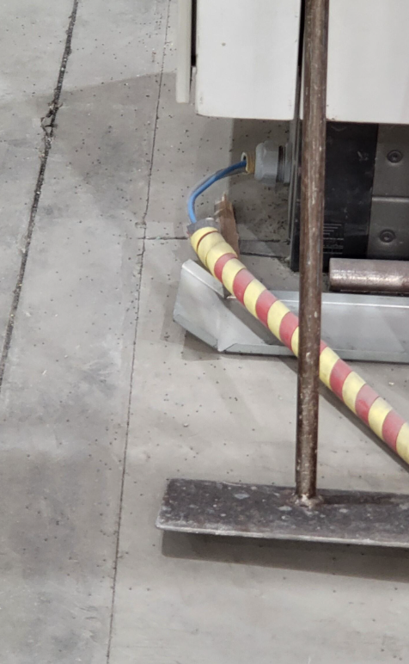 | 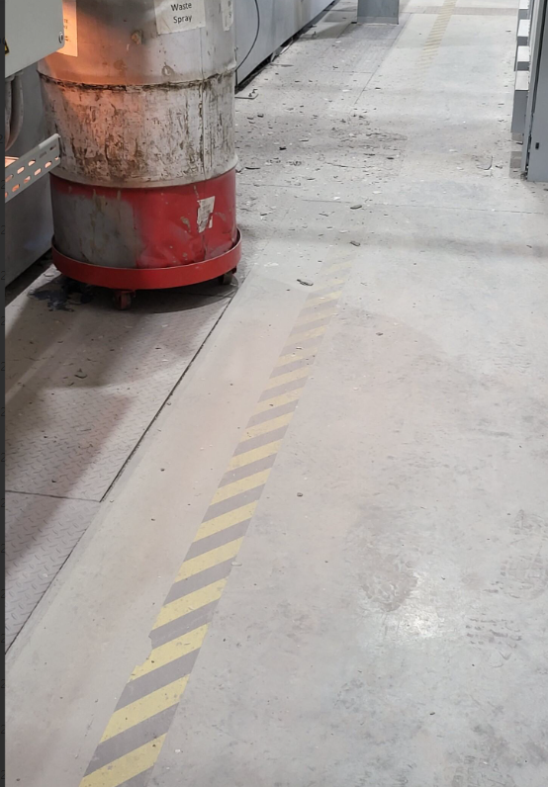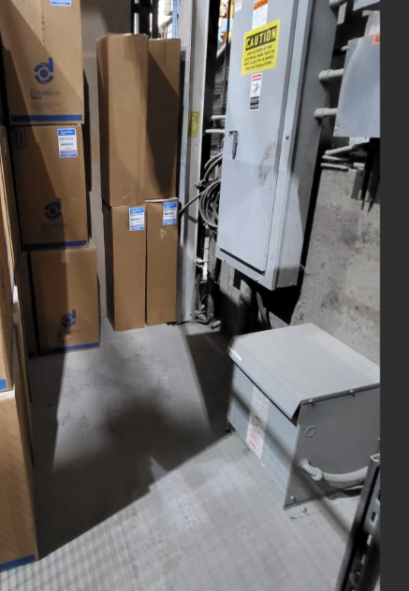
Damaged Conduit observed in APC at the Shot Blaster | Visual Management Tools of Light Curtains, Fire extinguishers, electrical panels need to be updated.
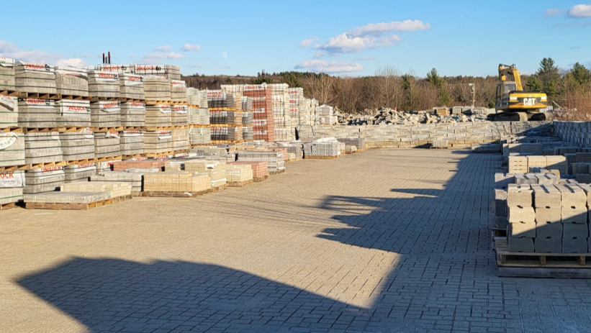 | 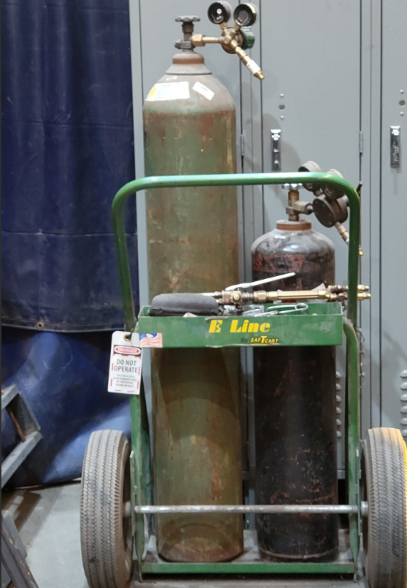
Yard Observed in good condition. | Maintenance Welding Cart with Regulators Left on tagged out of service

Appendix 1 Monthly Safety Talk Topics

Appendix 2 – Employee Safety Suggestions

January 2024 No new safety suggestions.

February 2024 No new safety suggestions

March 2024 Multiple Suggestions – See Minutes

April 2024 Consider a Yard AED – Truck Drivers – Response time.
`
May 2024 Multiple Suggestions – See Minutes – In progress.

June 2024 Add three fire extinguishers in Plant 4 per maintenance suggestion.

July 2024 No new safety suggestions.

Aug 2024 Add plexiglass to the shot blaster in APC to better contain overspray and material.

Sept 2024 Move the pad rack in the yard to deconflict forklift/pedestrian and truck traffic.

Oct 2024 Create a library of preprinted chemical labels employees can take and stick to secondary containers. Add fire extinguishers to the lunchrooms in both Plants.

Nov 2024 Eye washing station placed in all forklifts or in the shed by the fuel depot.

Dec 2024 No new safety suggestions.

