Install and Setup WPCRM on your Cell Phone

In Google Play search for Webpresented CRM and install it.

After installing it, click on icon to start WPCRM.

First time only you would have to enter the System Web address which is crm.bullergrp.com and click Continue.

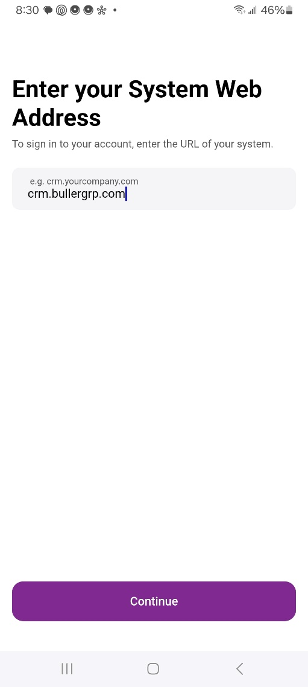
It will then bring up a list of companies. Choose Bullergrp1
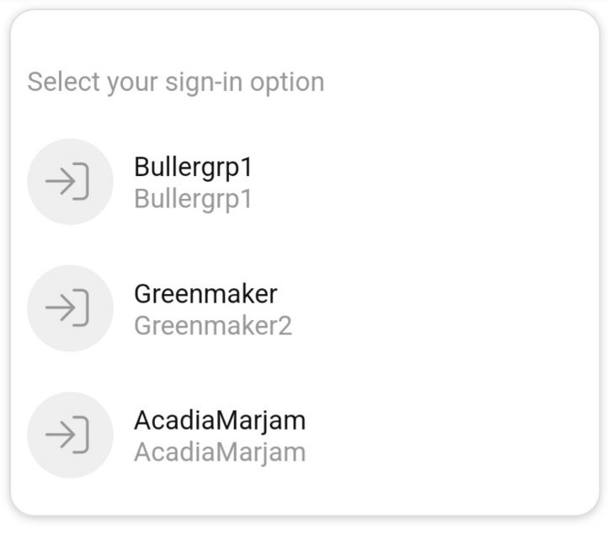

You can then sign in using your Outlook credentials.

