WPCRM – How to add email to open task

In the right upper corner click on the envelope
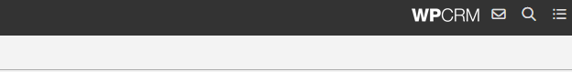
This should open up your email. Click on the file you wish to attach to the task

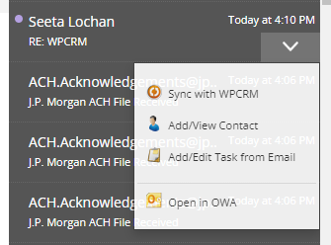

Click on Add/Edit Task from email and enter all necessary information and select update recently viewed task
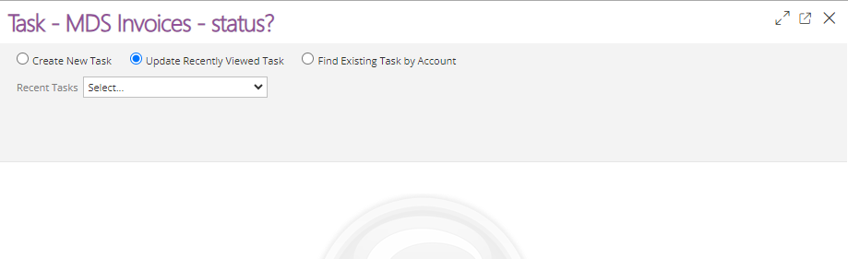
Click on recent task drop down and select your task – this should open up the task, scroll down and this should have the email attached.
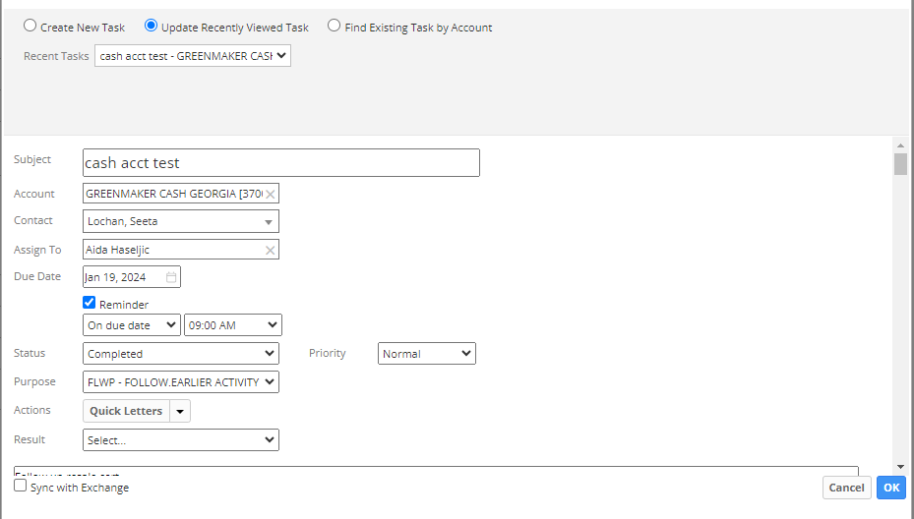

Click OK and this will update the task.

