Contact List in WPCRM
To extract a contact list from WPCRM and save it for future use, perform the following steps:
- In WPCRM click on Contacts and then on Locate. 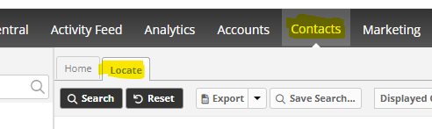
- If the Filters is not expanded, click on the + sign next to it.
- In the Filters section, you can select as many options as you want depending on how granular you want to get. In this search I am just going to get all contact in Greenmaker Whse 4. 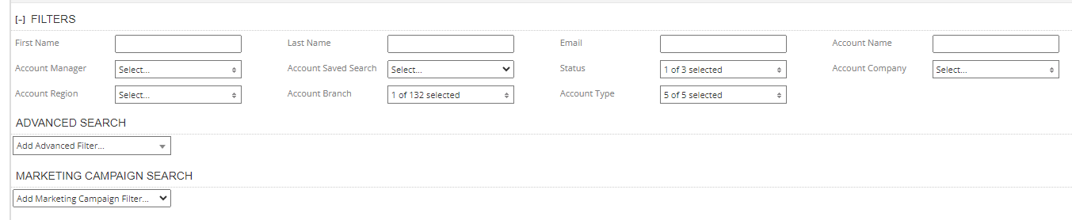
- So in Account Company click on the dropdown and select 3700 – Greenmaker and then click on Apply

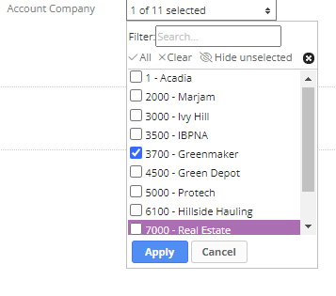

- In Account Branch, click on the dropdown and select 3700 – 004 – W. Hartford, CT and then click on Apply. 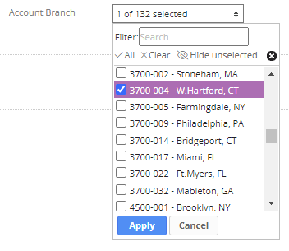
- Under ADVANCED SEARCH, you can select any of those options. Since we are looking for an email list, we will select Email Status and under Email Status we can select Has Well-Formed Email. And click in Search. 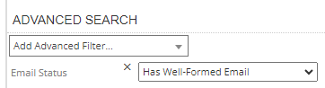

- After the list is displayed, click on Save Search. 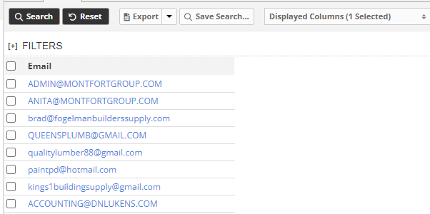
In the Save Search screen select Create new saved search, enter a name, select Save as shared search and click on OK. 