How to edit Oerob Data: ( same procedures can be used for all other Keyword Edits )

Go to View:

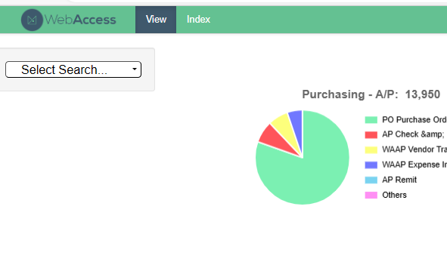
Click on Select Search Greenmaker OE OEROB Report

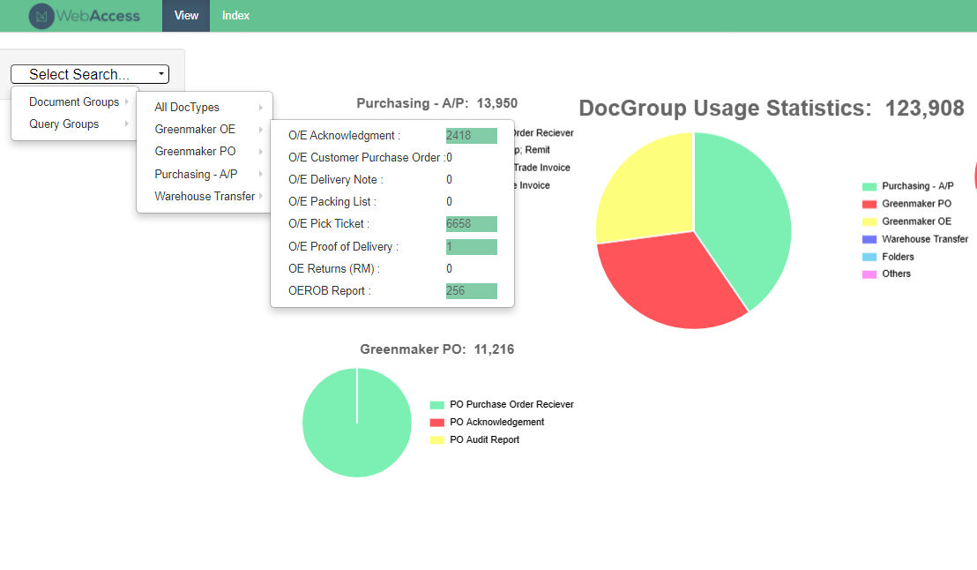
Click on Search:

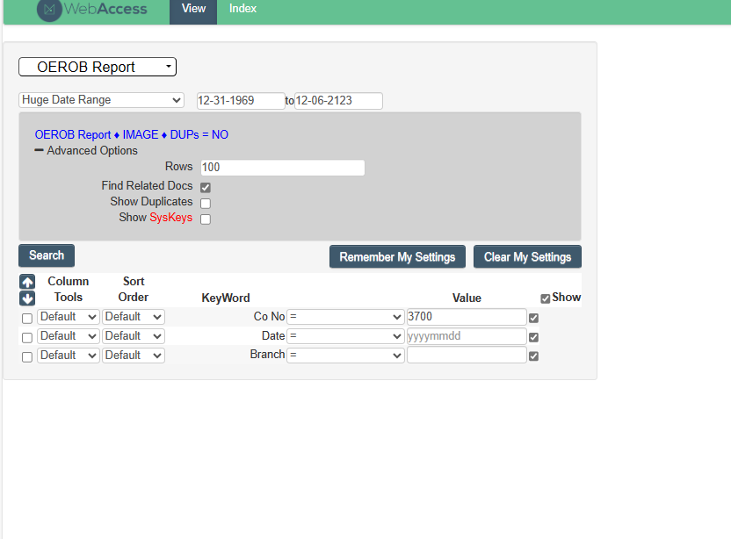
Select the report you wish to Edit and open it.
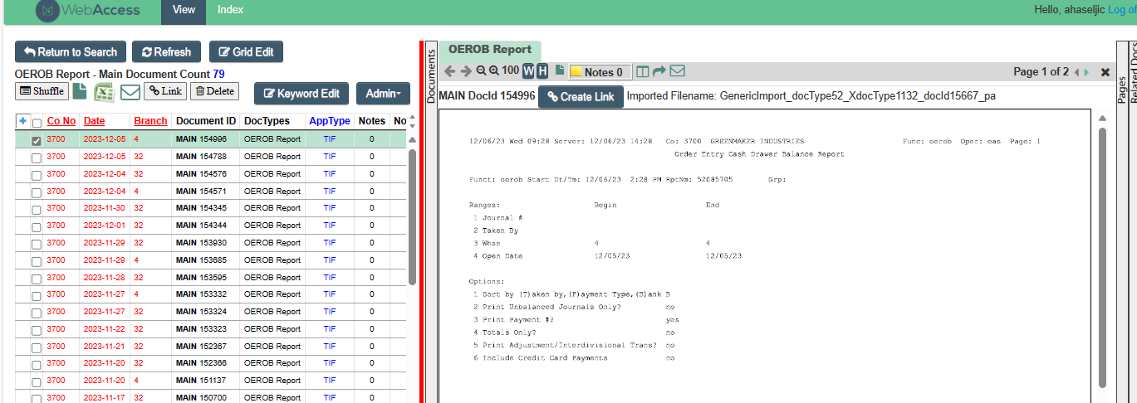

Click on Keyword Edit Admin Edit Key Fields
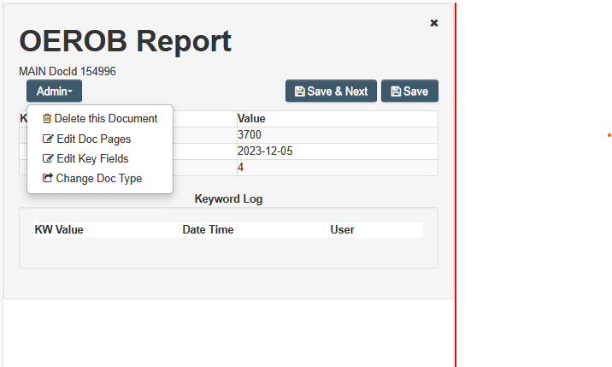
Make the needed changes and click Save.

