WPCRM – Adding Credit Documents

- From the Accounts Tab, select your customer
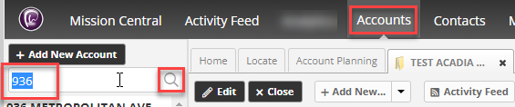

- Go to the contacts for this customer
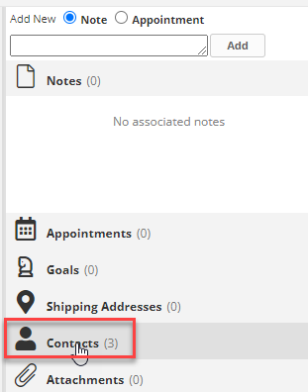

- If no CREDIT DOCUMENTS contact exists, you must create one
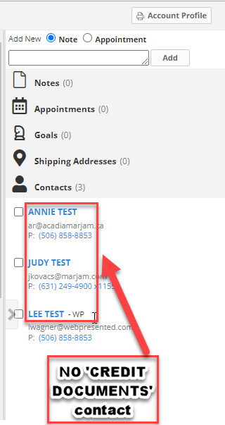

- Select Add New at top of contacts screen and select Contact
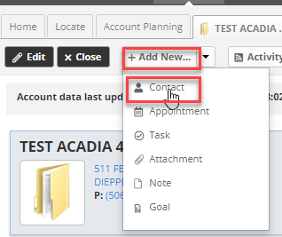

- Contact window opens
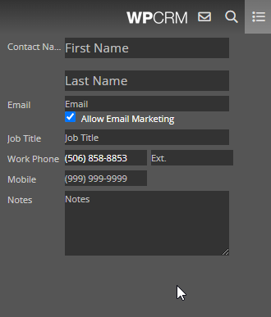

- Enter Contact First name as CREDIT and last name as DOCUMENTS Please do not forget the “s” in documents.
- Unckeck Allow Email Marketing
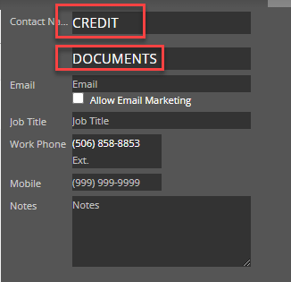

- Add any notes if needed on supporting documents.
- Click ok at the bottom right when done creating contact.
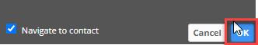

- Contact is created and now you can add attachments to this customer under this Credit Documents

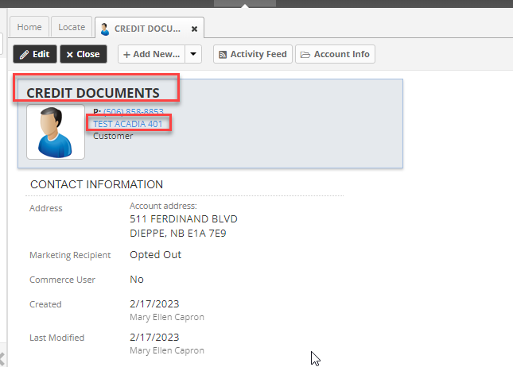

- Customer Name is under the Contact name
- Click in Add New and select Attachments
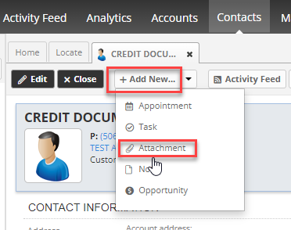
- New Attachment window opens
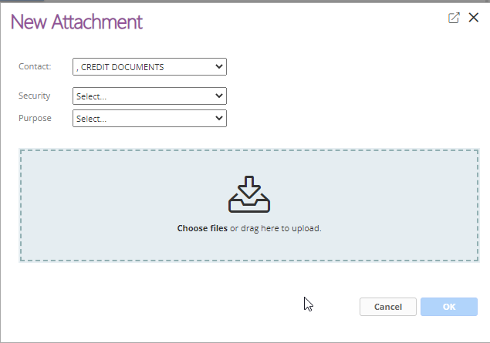
- Security must be selected. This is extremely important!
  - When left with Select everyone can see it that has access to WPCRM. This is for non sensitive information documents such as tax exempt form, W9, prospect entry form, etc.
  - Reg Credit is used for sensitive but non personal information such as credit related documents that do not have sensitive information on it such as statement, credit references, Insurance Information, and bond information. Be sure to check each document carefully. If it does not contain any personal information protected by the law, such as income, EIN or SS numbers, etc it can be put with this security level. This includes credit applications at this time, but the credit application must be moved to Corp Admin security once it has been fully processed.

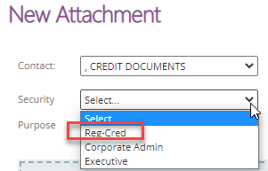

  - Corporate Admin – this security does contain sensitive personal information, such as a Driver’s license, passport, credit card numbers and a fully processed credit application.
  - Executive

- Select a purpose from the dropdown
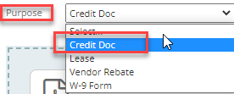

- To upload a document, click in the area to choose files.


- Click OK when done to save it.
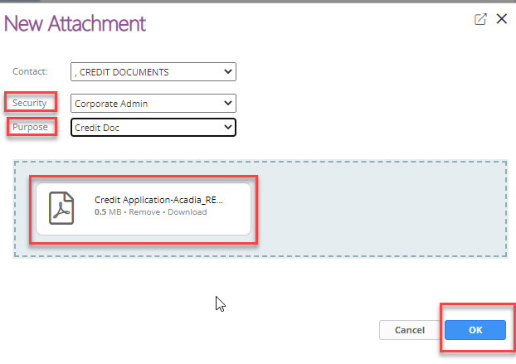

- Document has been uploaded appears.
- Option to add another document or
- Close the window

