OEROB - Cash Drawer Balance Report

This report lists all Journals that were tendered for the day. Verify that the day’s OEET Journal/s has been closed (see step 13 on page 4). THIS MUST BE DONE so the OE Cash Drawer Balance Report can be processed.

1. Access OE Cash Drawer Balance Report. Type OEROB into the search bar and press ENTER.
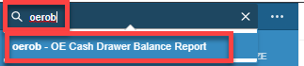

The OE Cash Drawer Balance Report appears with a listing of stored OEROB Reports for each warehouse.

2. Locate your branch report by location and select the box on the left of its name. A check mark appears.

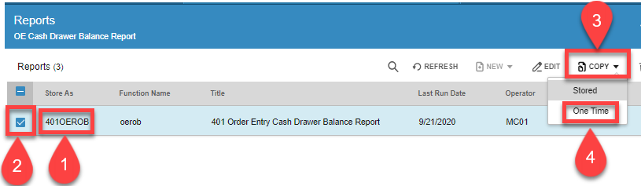

3. Click the arrow next to Copy, Select One Time

4. Verify Print is displayed inside the Printing Information entry.

Your laser printer should appear in the second Printing entry.

- If needed, type your laser printer OR click the Lookup and click your printer to select.
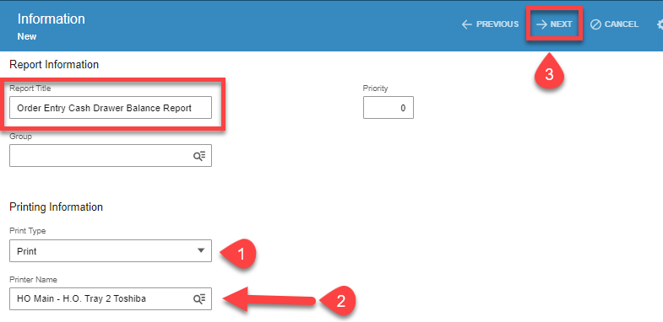
5. Click Next. The Range page displays. Verify the correct data is stored or change as needed.

The Open Date should display *** through the date entries. This indicates the report is to process only the Journals closed today.

- Change the date range if needed.

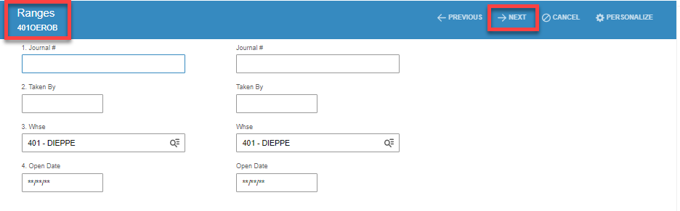

6. Click Next. The options page displays. Verify selections and click Next to proceed.

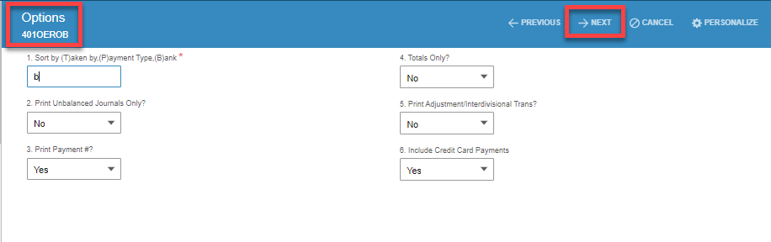

The report Run page displays.. A job number is assigned from the system. Click SAVE to run the report. It prints to the specified printer.
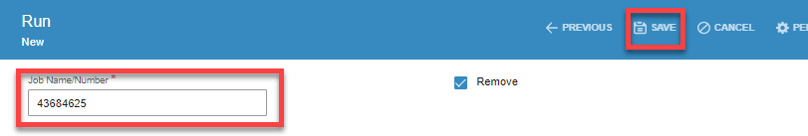

- Review Journal and Register totals.

- Send the report and attach deposit slips to AR Analyst.

Sample of OEROB

